CREATE TABLE JOB ( Names VARCHAR(20), Department_ID NUMERIC ,Salary NUMERIC);

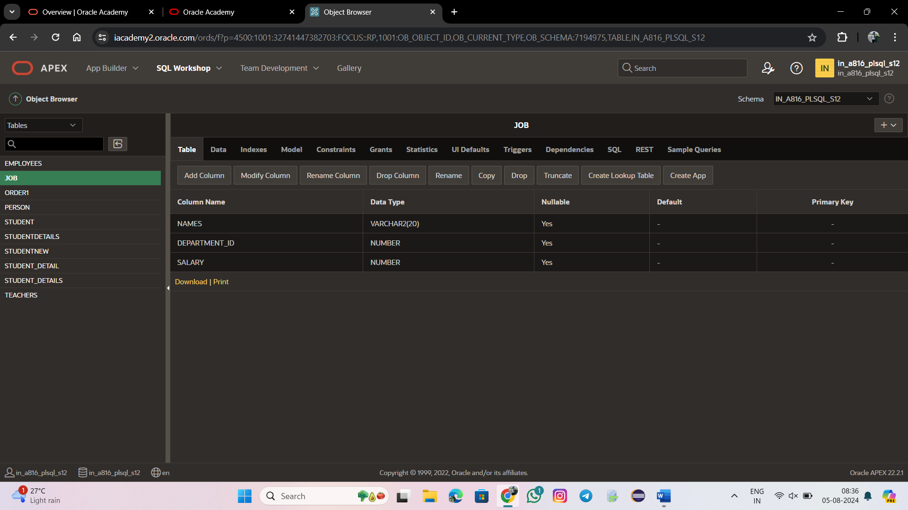

INSERT INTO JOB VALUES('Sarshini',90,250000);

INSERT INTO JOB VALUES('Meshalisurya',70,500000);

INSERT INTO JOB VALUES('Sugin',89,490000);

INSERT INTO JOB VALUES('Vimal',67,700000);

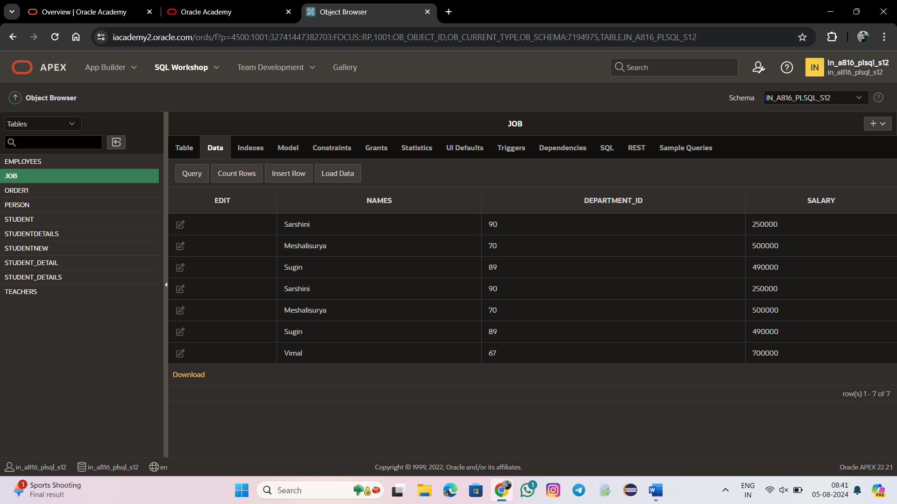

SELECT MIN(Salary)FROM JOB;



SELECT MAX(Salary)FROM JOB;



SELECT AVG(Salary)FROM JOB;



SELECT Department_Id ,MIN(Salary)

FROM JOB

WHERE Salary>=1000

GROUP BY Department_Id;

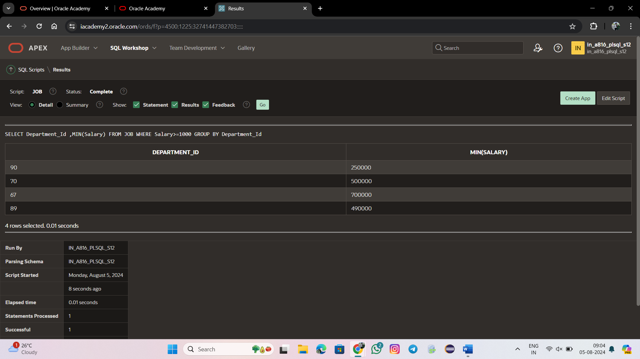

SELECT COUNT (Department_Id)

FROM JOB;

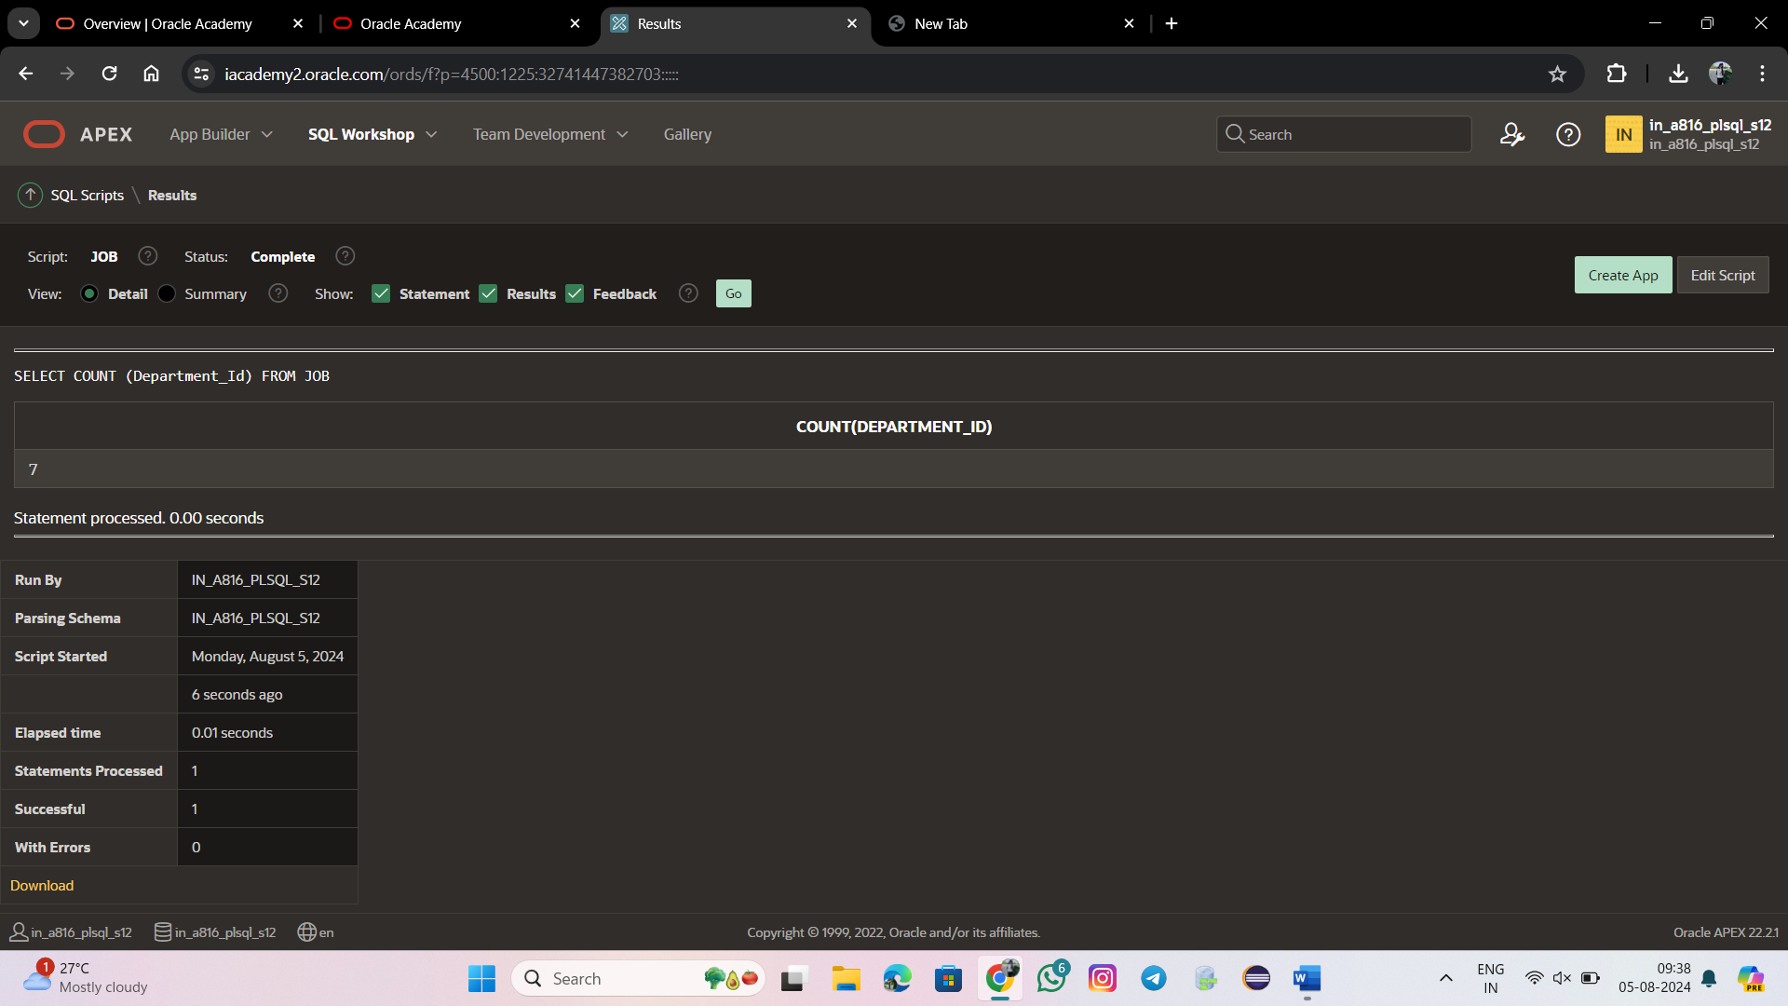

SELECT DISTINCT Salary

FROM JOB;

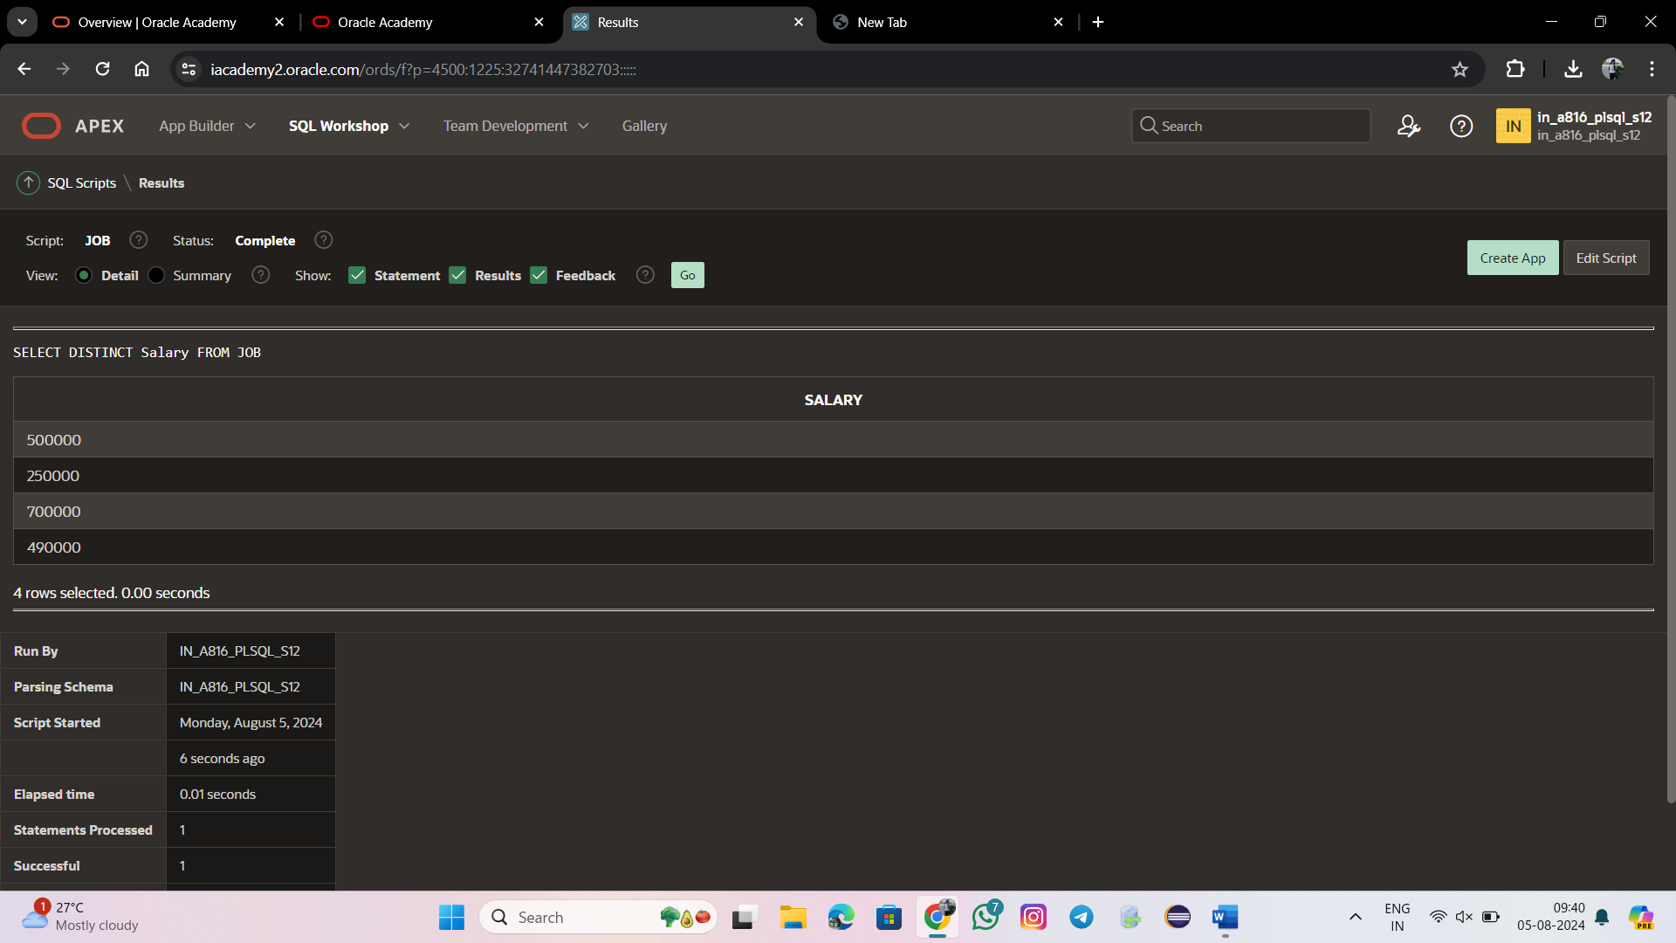

SELECT AVG (NVL ( DEPARTMENT_ID,0)) FROM JOB;

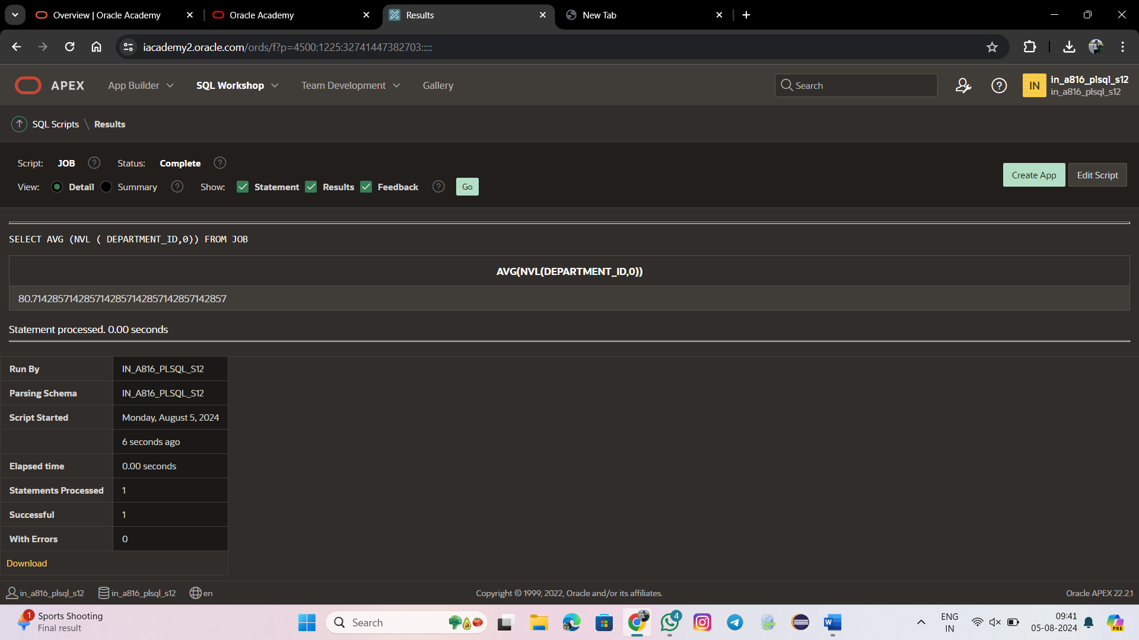

SELECT Department_Id, AVG(Salary)

FROM JOB

GROUP BY Department_Id

ORDER BY Department_Id;

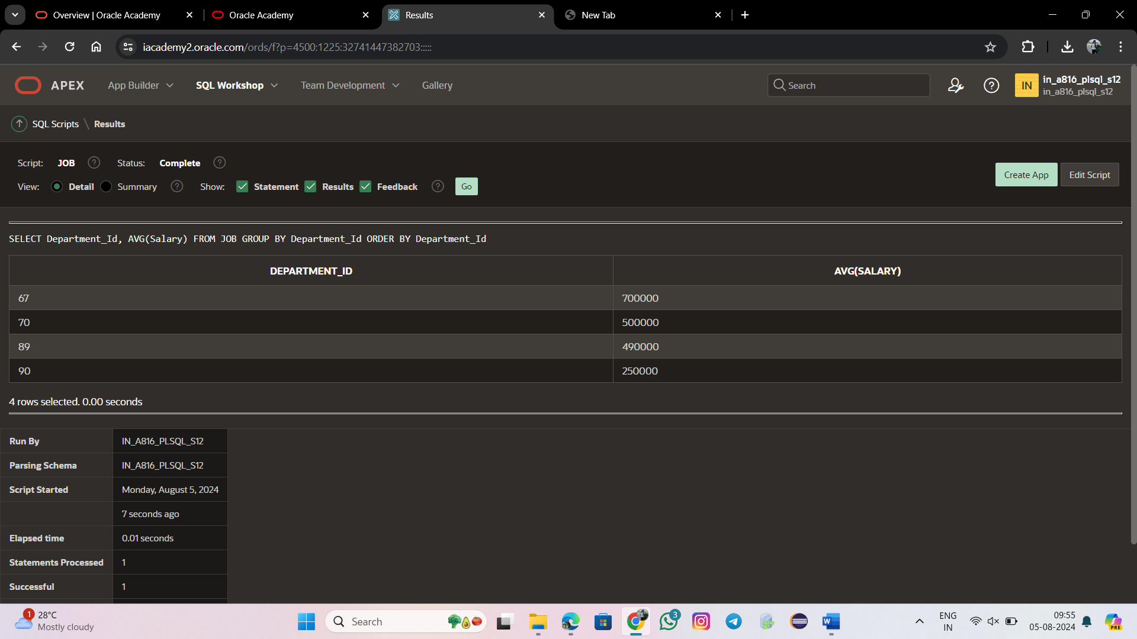

SELECT Department_Id, MAX(Salary)

FROM JOB

GROUP BY Department_Id;

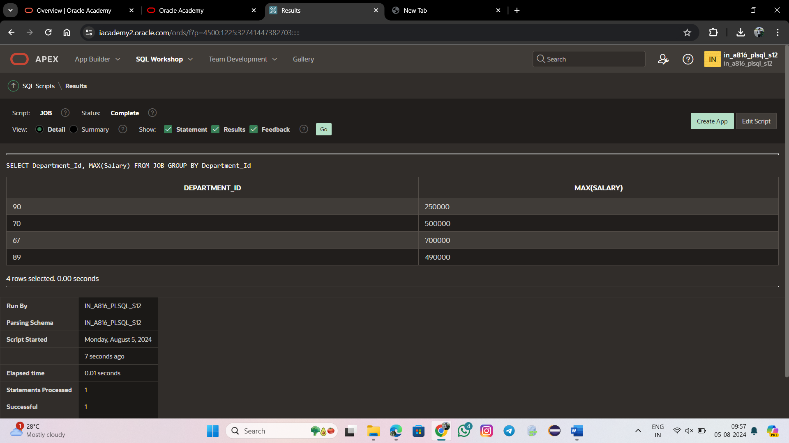

SELECT MAX(Salary),Department_Id FROM JOB WHERE Names!='Sarshinni' GROUP BY Department_Id;

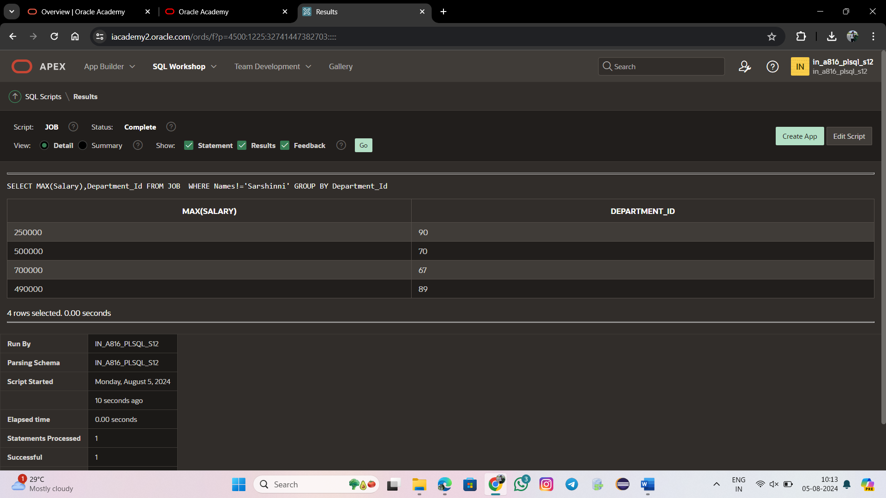

SELECT MAX(AVG(Salary))FROM JOB GROUP BY Department_Id;



SELECT Department_Id,MAX(Salary)FROM JOB GROUP BY Department_Id HAVING COUNT(*)>=1 ORDER BY Department_Id;

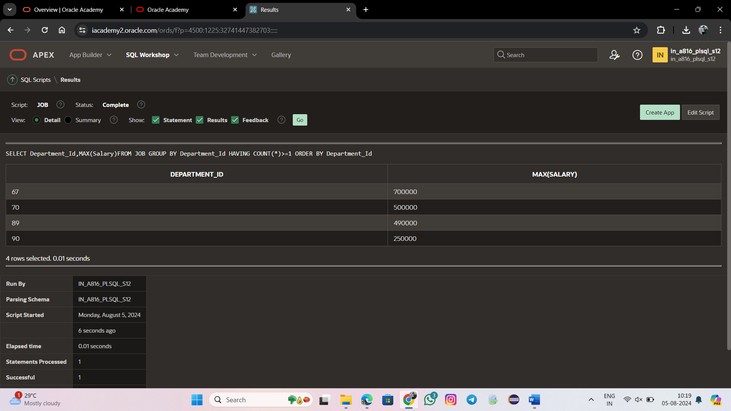

SELECT Department_Id, Job_id, SUM(salary)

FROM JOB

WHERE Department_Id > 50

GROUP BY ROLLUP (Department_Id, Job_Id);

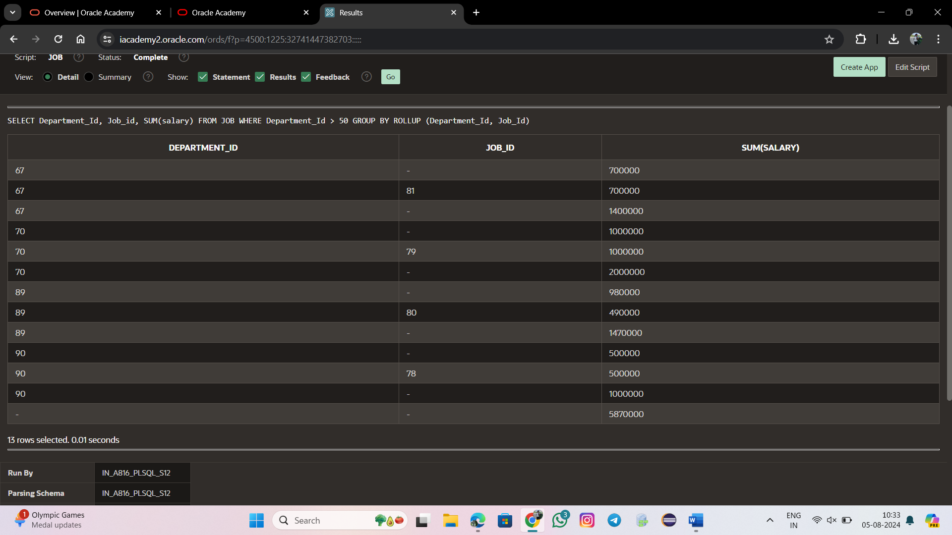

SELECT Department_Id, Job_id, SUM(Salary)

FROM JOB

WHERE Department_Id > 50

GROUP BY (Department_Id, Job_Id);

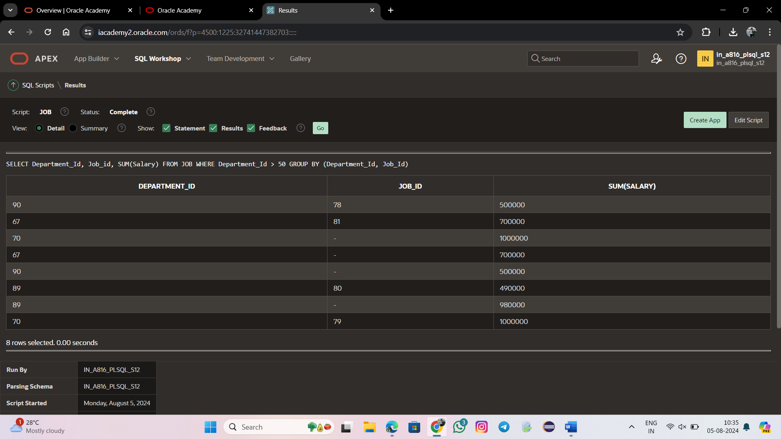

SELECT Department_Id, Job_Id, SUM(Salary)

FROM JOB

WHERE Department_Id > 50

GROUP BY CUBE (Department_Id, Job_Id);

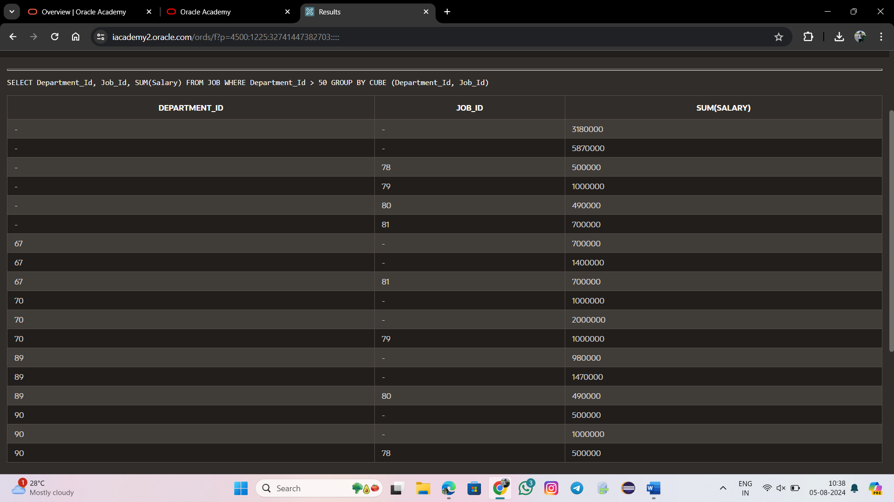

SELECT Department_Id, Job_Id, SUM(salary)

FROM JOB

WHERE Department_Id > 50

GROUP BY GROUPING SETS

((Job_Id, Job_Id),(Department_Id, Job_Id),

(Department_Id, Job_Id));

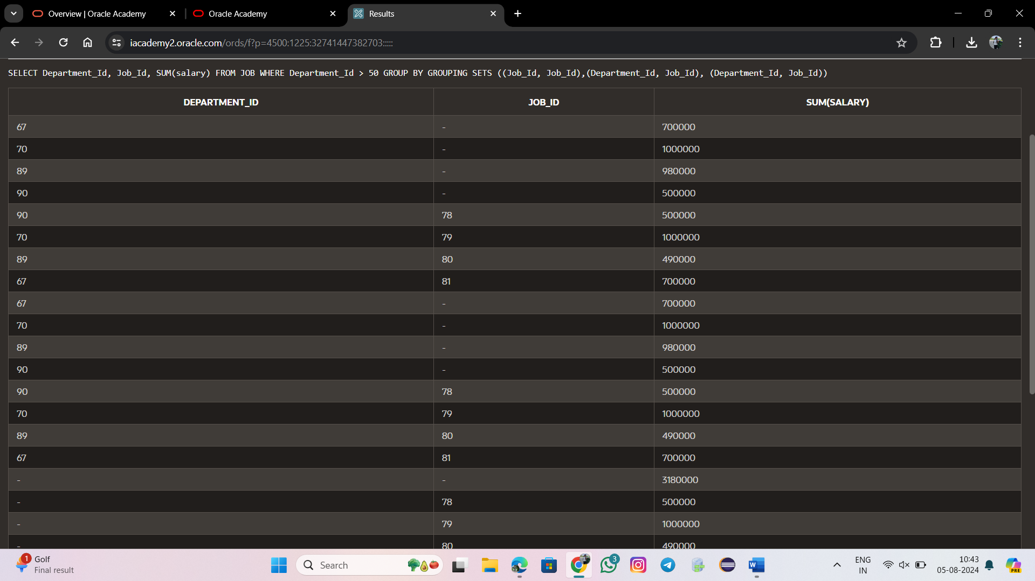

SELECT Names, Department_Id, Job_Id

FROM JOB

UNION

SELECT Names ,Department_Id,

Job_Id

FROM JOB;

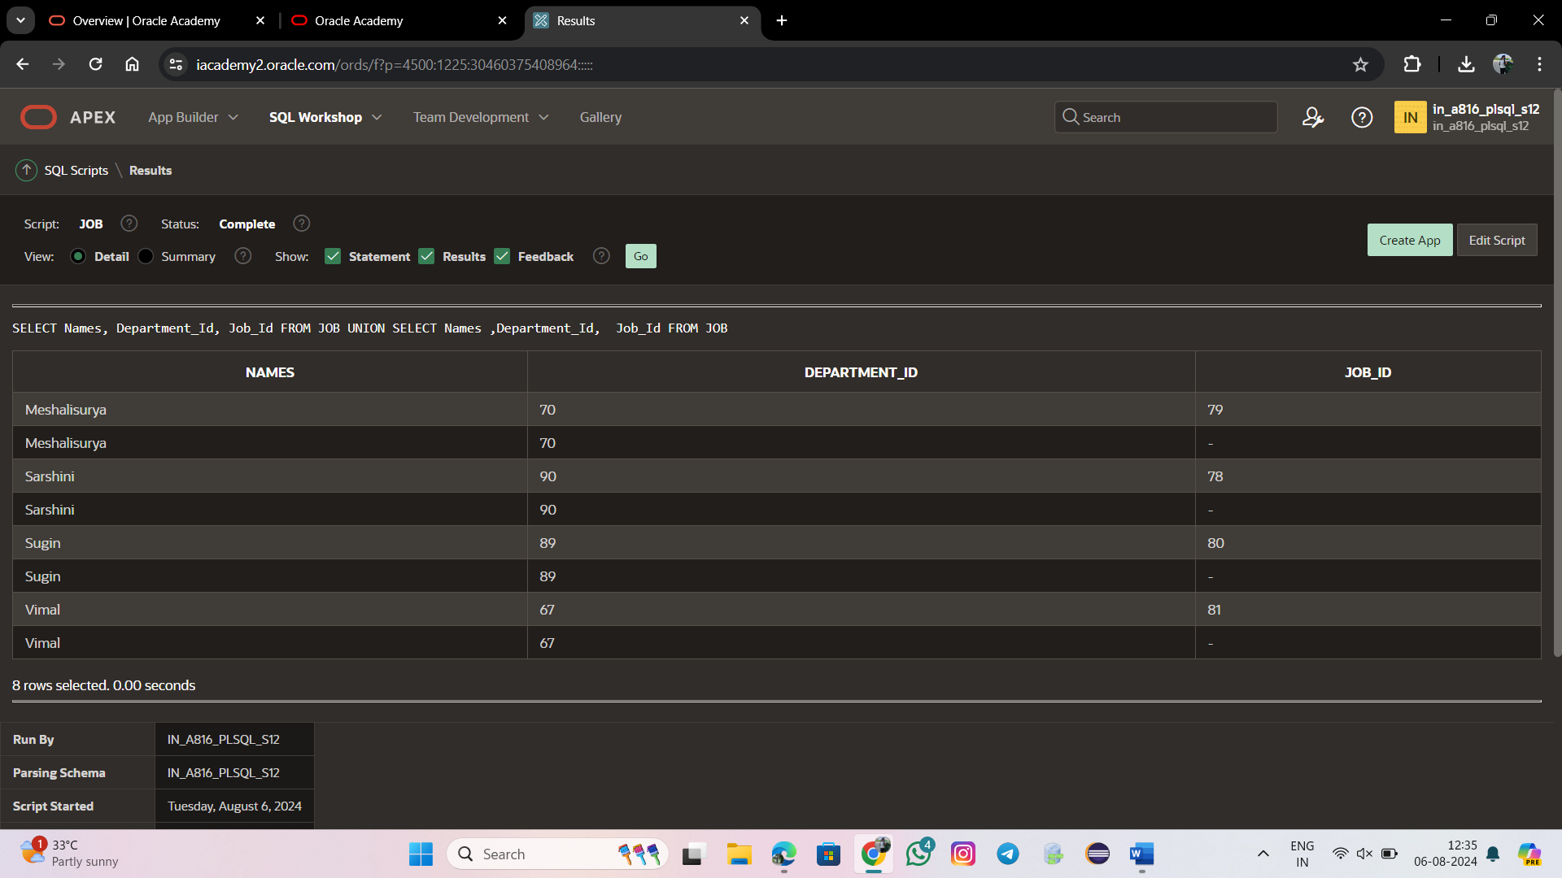

SELECT Names, Department_Id, Job_Id

FROM JOB

UNION

SELECT Names ,Department_Id, Job_Id

FROM JOB

ORDER BY Department_Id;

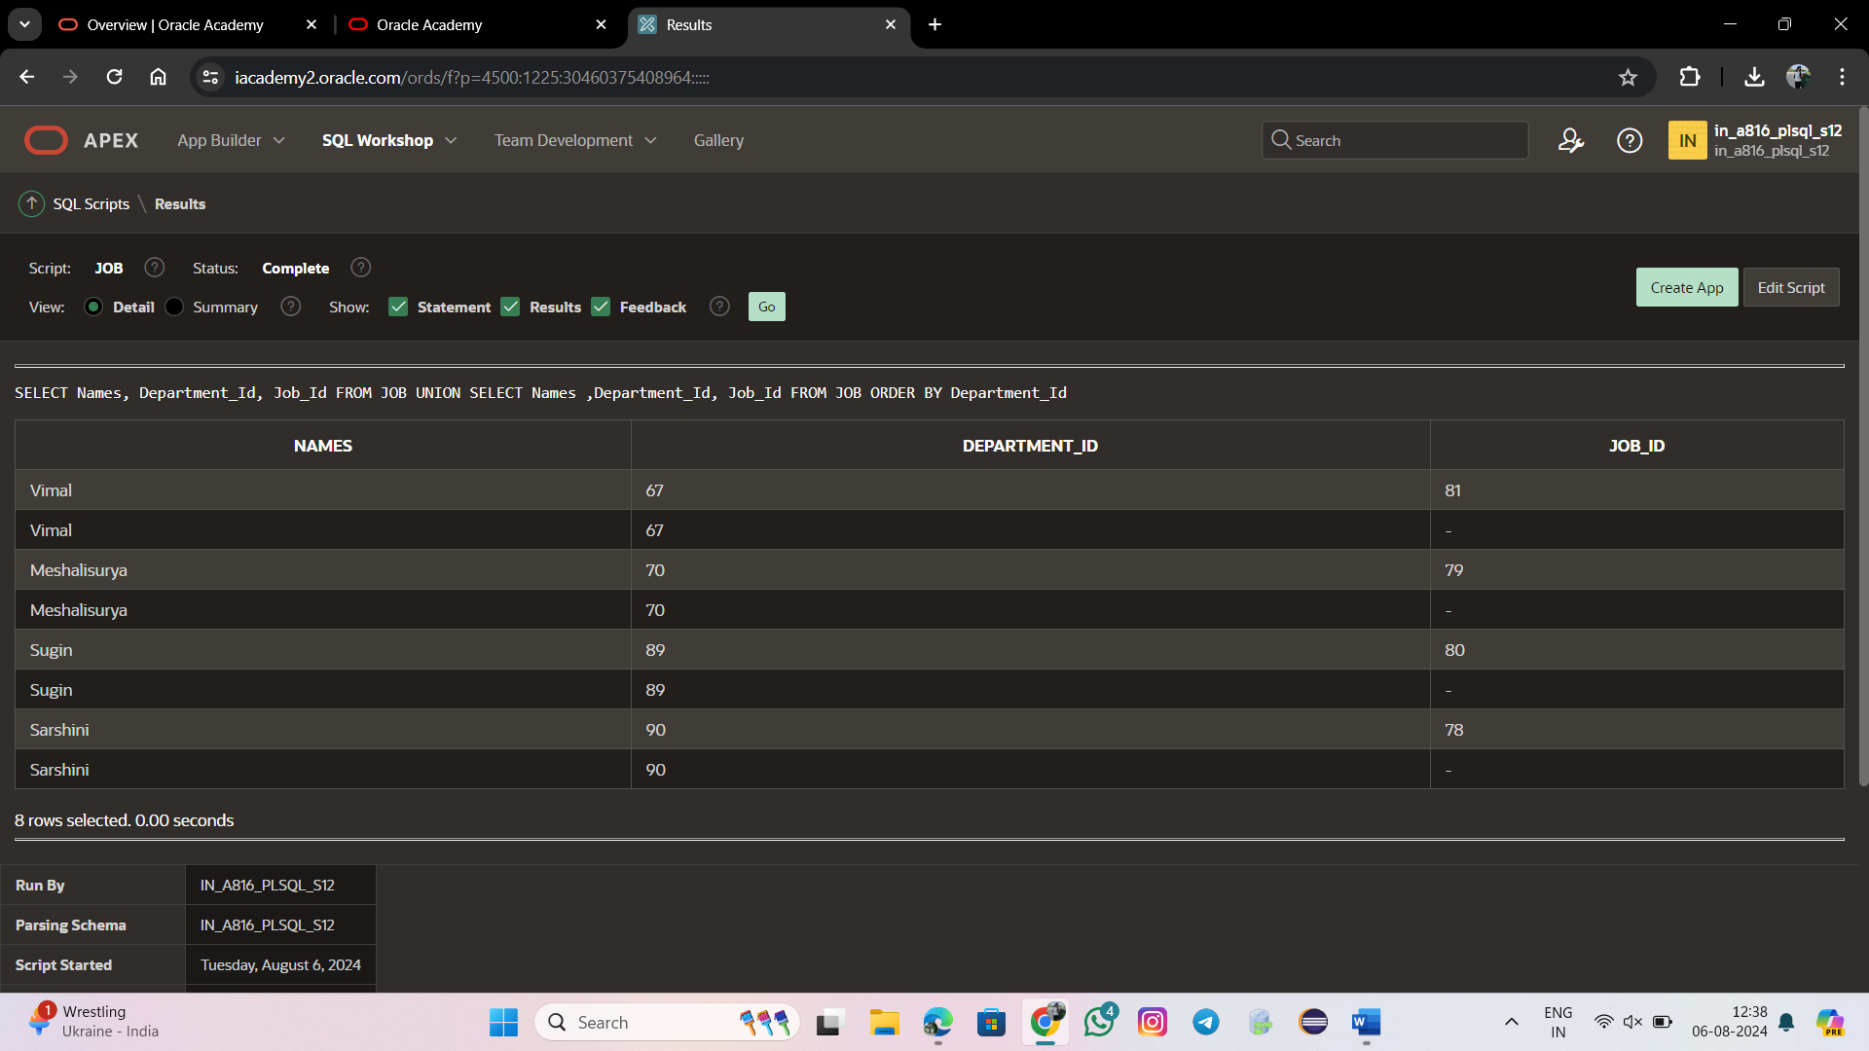

SELECT Job_Id

FROM JOB

UNION

SELECT Department_Id

FROM JOB;



SELECT Job_Id

FROM JOB

UNION ALL

SELECT Department_Id

FROM JOB;



SELECT Job_Id

FROM JOB

INTERSECT

SELECT Department_Id

FROM JOB;



SELECT Job_Id

FROM JOB

MINUS

SELECT Department_Id

FROM JOB;

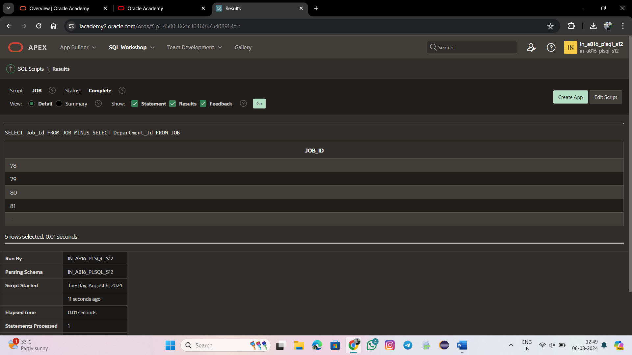

SELECT Department_Id FROM JOB

WHERE Department_Id < (SELECT Department_Id FROM JOB WHERE Names ='sugin');

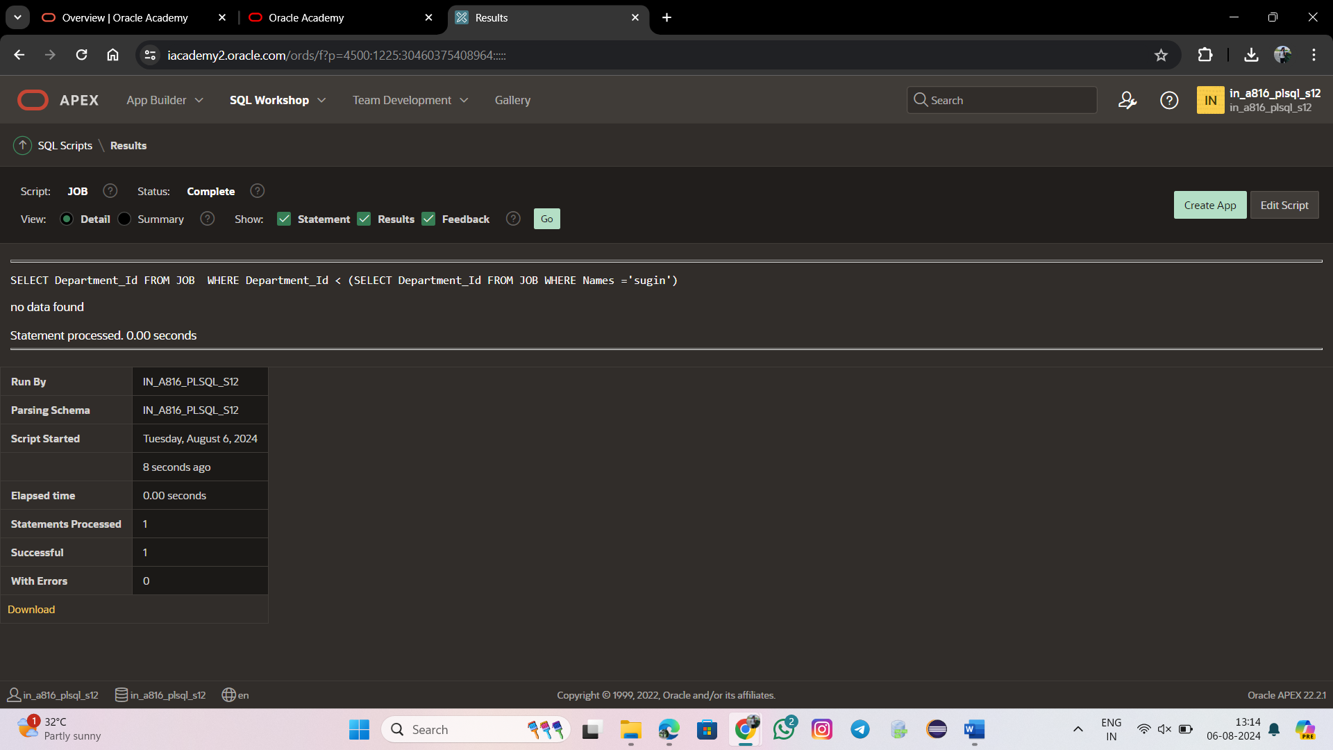

SELECT Names

FROM JOB

WHERE Department_Id =

(SELECT Department_Id

FROM JOB

WHERE Names = 'sarshini');

